1. Overall classification accuracy:

House Votes Manual: 0.592529

House Votes Naive: 0.546586

House Votes PC: 0.546586

2. Sensitivity and specificity for each of the two parties

|  |  |  |  |  |
| --- | --- | --- | --- | --- |
|  | Democratic | | Republican | |
|  | Sensitivity | Specificity | Sensitivity | Specificity |
| House Votes Manual | 96.63% | 95.24% | 95.24% | 96.63% |
| House Votes Naive | 89.12% | 91.67% | 91.67% | 89.12% |
| House Votes PC | 95.88% | 95.83% | 95.83% | 95.88% |

3. Positive and negative predictive value for each of the two parties

|  |  |  |  |  |
| --- | --- | --- | --- | --- |
|  | Democratic | | Republican | |
|  | Positive | Negative | Positive | Negative |
| House Votes Manual | 96.99% | 94.67% | 94.67% | 96.99% |
| House Votes Naive | 94.44% | 84.15% | 84.15% | 94.44% |
| House Votes PC | 97.34% | 93.60% | 93.60% | 97.34% |

4. Calibration curve for a selected bin count or window size

House Votes Manual:

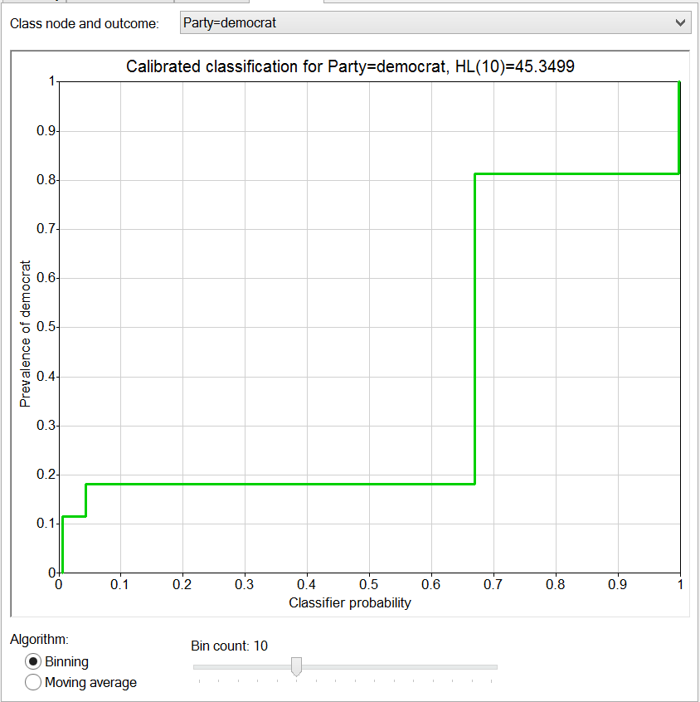

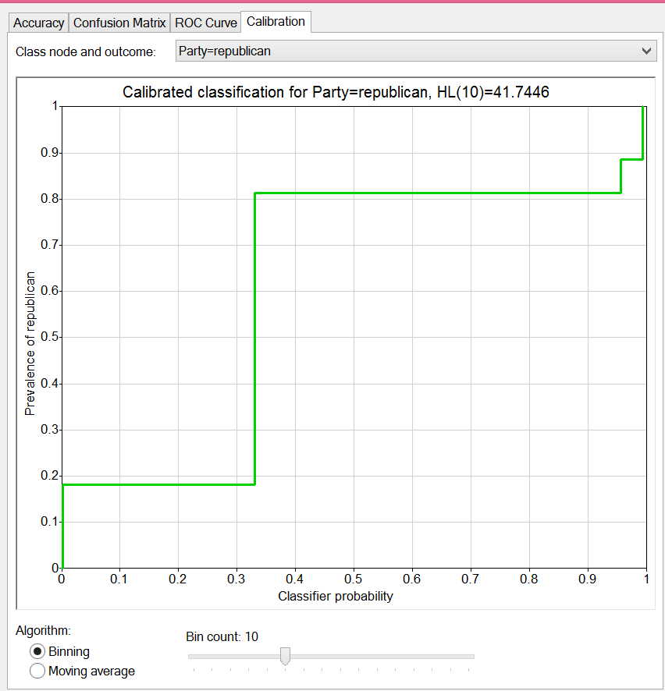

House Votes Naive:

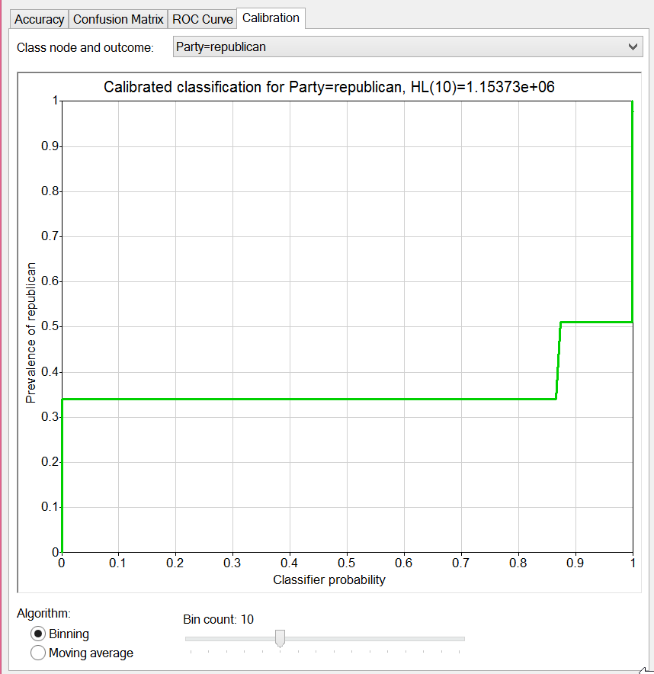

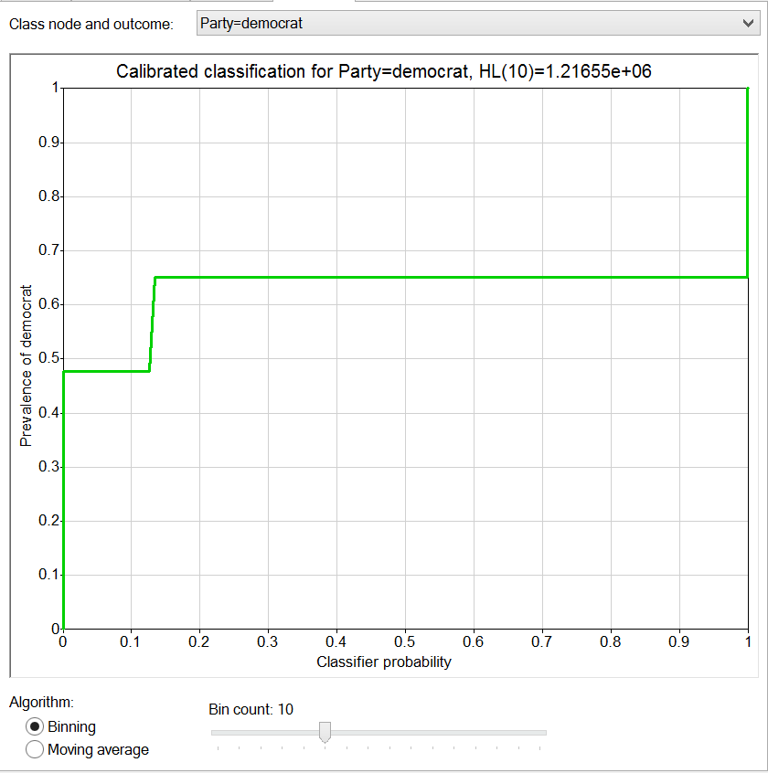

House Votes PC:

